Chapter 10, Solution 65.

Using Fig. 10.108, design a problem to help other students to better understand Norton’s theorem.

Although there are many ways to work this problem, this is an example based on the same kind of problem asked in the third edition.

Problem

Compute i_{o} in Fig. 10.108 using Norton's theorem.

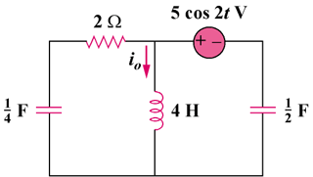

Figure 10.108

Solution

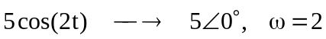
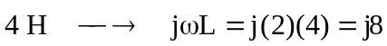
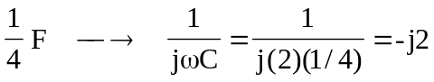
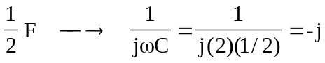

To find 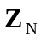, consider the circuit in Fig. (a).
(a)
-j 
-j2 
2 
Z_{N}
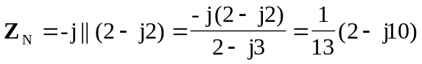
-j 
50 V
-j2 
I_{N}
(b)
+ 
2 
To find 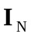, consider the circuit in Fig. (b).
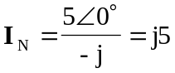

The Norton equivalent of the circuit is shown in Fig. (c).
Z_{N}
j8 
I_{N}
I_{o}
(c)

Using current division,
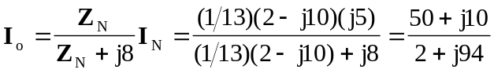

Therefore, 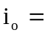 542 cos(2t – 77.47) mA

